Name: Nguyen Duc An

Student ID: 281958007

Computer Aided Engineering Class – Final Report

Elastic Problem

1. **Introduction:**

In this report, the task is to analyze a desired 2D object in term of elasticity deformation using Finite Element Method (FEM). The object was chosen to be a hook with non-linear cross section.

1. **Process:**

The shape was designed as shown below using FreeCAD program, with the parameters written in Fig. 1

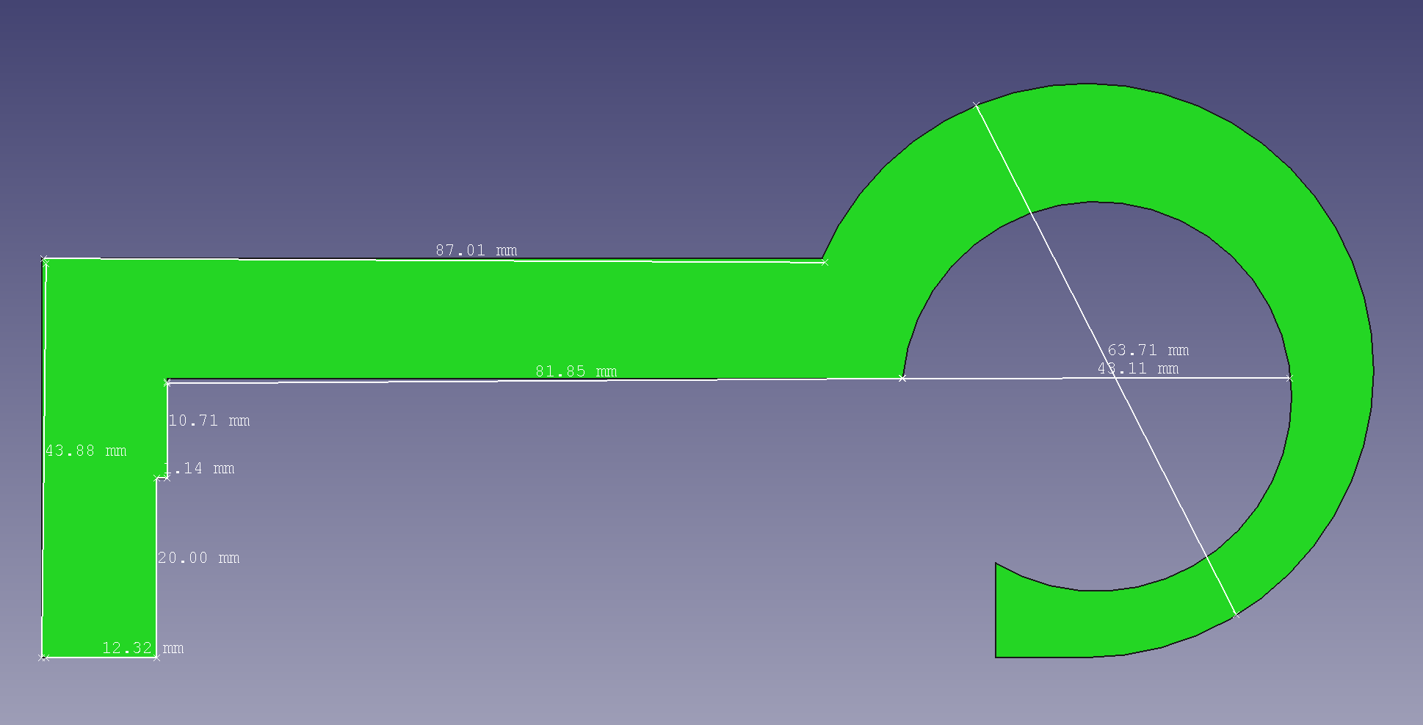

Fig. 1 Input Object created in FreeCAD

Feritas Input File:

* Elasticity was selected (Code 2).
* Dimensionality was set at 2.
* Material were set as default (alpha = 10.0e-6; v = 0.30, E = 210.0e9)

From FreeCAD software the .csv file was outputted with:

* Number of Node: 199
* Number of Elements: 286
* Number of Surface Elements: 109

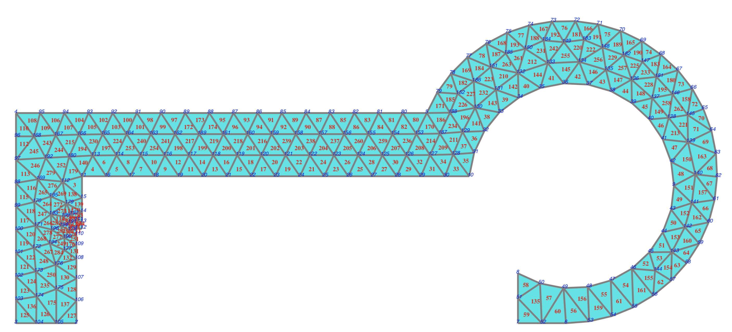

Fig. 2 Nodes Position

The Boundary condition were set to fix the left hand side inner circle edges nodes (40-45), and apply force 1.0E7 N to the right hand side edges (4,96-103,4) in the negative x direction.

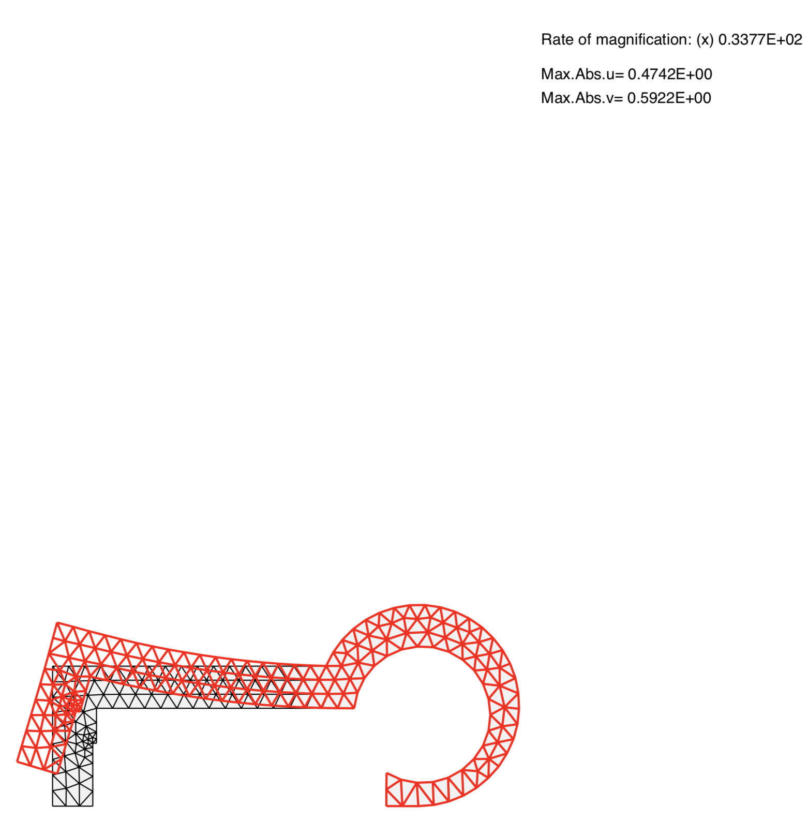All the other points were set to move in freedom.



Fig. 3 Deformation according to boundary conditions

1. **Result:**

The deformation result and stress distribution were shown in Fig. 3 and Fig. 4, using *Feritas* by T. Matsumoto.

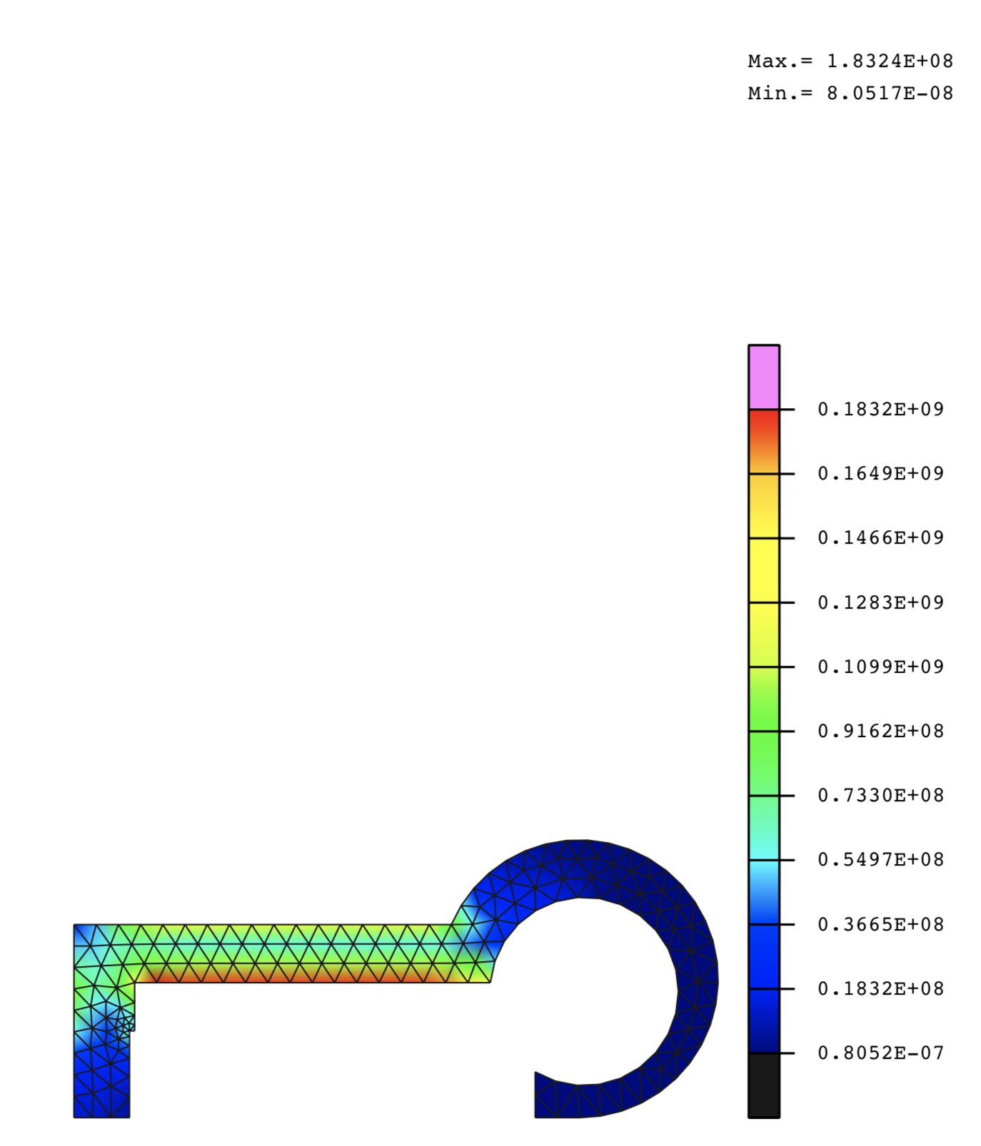

Fig. 4 Stress Distribution

1. **Discussion:**

It can be seen from Fig. 4 that, the simulation of dragging an object using a hook will mostly put the stress on the connecting bar between the hook and the handle.

Also as the inner side of the circle was set as fixed point or the pivot, even though the forces were applied homogenously on the outer surface of the handle, the displacement seems to move upward.

1. **Reference:**

[1] [FEM source for MacOSX and Linux, commented in English](http://be.m.nuem.nagoya-u.ac.jp/ad/Feritas-e.zip), T. Matsumoto, Nagoya University.

[2] Feritas Software Instruction, T. Matsumoto, Nagoya University.